Here’s a new workout for the week!
Roll for Fitness
Directions: Roll two dice and add numbers together.
The sum of the dice determines the exercise movement.
Roll a 2: 5 push-ups
Roll a 3: 15 sit-ups
Roll a 4: 15 squats
Roll a 5: 20 mountain climbers
Roll a 6: 10 burpees
Roll a 7: 25 star jumps
Roll an 8: 20 lunges
Roll a 9: 30 side jumps
Roll a 10: 20sec plank hold
Roll an 11: 50 jumping jacks
Roll a 12: 30 sec high knees

Have you had a go at one of the Les Mills Born to Move videos yet? If not, you can always tune into TV 2 at 3pm each week day! Get your family and siblings involved too :)

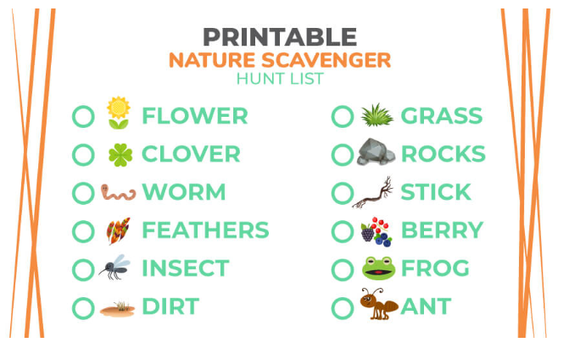
This week while you are out on your walks, how about trying a scavenger hunt? If you have a printer at home, print one off and give it a go! Of course you do not need a printer, get some paper out and write down the list! :)

Website below:
https://kidactivities.net/printable-nature-scavenger-hunt-list/

And here is an inside scavenger hunt:
https://jujube.com/blogs/community/make-your-own-indoor-scavenger-hunt

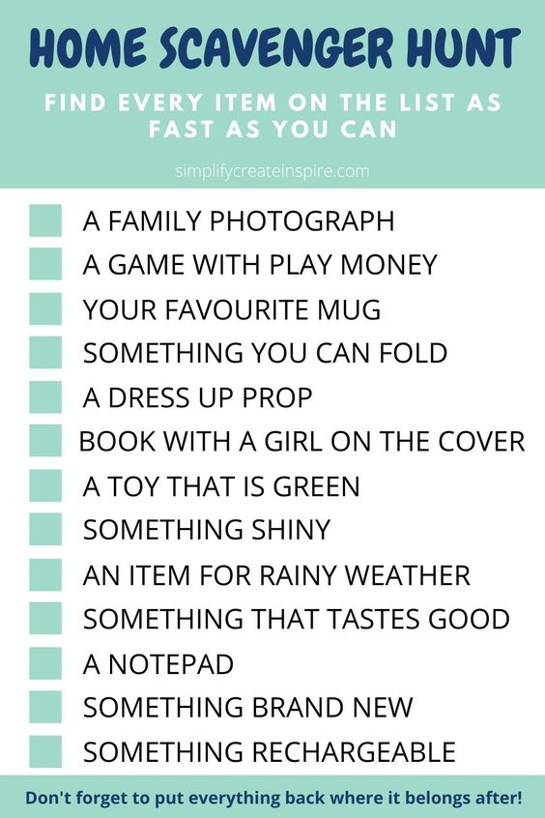

Here’s another activity:
Do you have PAINTERS TAPE/MASKING TAPE? CHALK?
If you have painter tape at home, create shapes on the floor for your children to follow, balance on, create a path in and around the living room to their room? can they freeze into a funny shape? How long can they hold that balance/shape for?
Also, if you have a free wall at home, use the painters tape to make out letters and numbers. You can ask your children to spell out words by throwing rolled up socks, using a nerf gun or a soft toy to each letter AND for the numbers – give them a simple math question and they can answer it by hitting the numbers that are taped on to the wall.
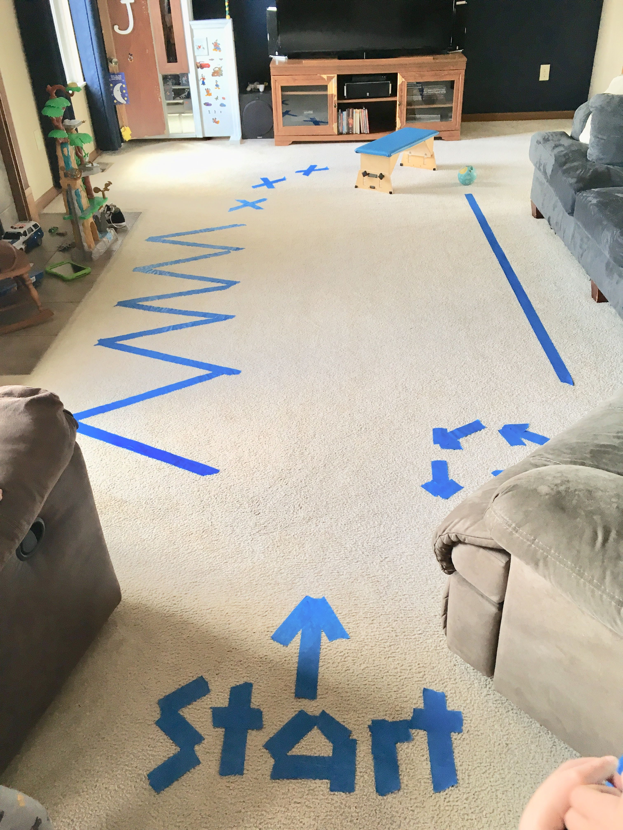
You can also do this outside with chalk on the ground or on the side of the house (if it is brick).
